SQL DATA PREPARATION REPORT: JAXON REAL ESTATE SALES & OPERATIONS ANALYSIS

BY
TECHCRUSH C3 DATA ANALYTICS GROUP 11

TABLE OF CONTENTS
LIST OF TABLES iii
LIST OF FIGURES iv
1.0 INTRODUCTION 1
1.1 Project Overview 1
1.2 Project Objectives 1
1.3 Dataset Description 1
2.0 DATA IMPORTATION 3
2.1 Database & Table Creation 3
2.2 Data Loading 3
2.3 Import Validation 4
3.0 DATA CLEANING & PREPROCESSING 5
3.1 Identification of Missing Values 5
3.2 Conversion of Invalid Values to NULL 6
3.3 Missing Data Assessment 6
3.4 Cross-Column Value Imputation 7
3.5 Median-Based Price Imputation 9
3.6 Secondary Median Imputation 11
3.7 Validation of Cleaned Dataset 12
4.0 DATA NORMALIZATION (THIRD NORMAL FORM) 13
4.1 Customers View 13
4.2 Agents View 14
4.3 Properties View 14
4.4 Transactions View 15
4.5 View Verification 16
5.0 DATASET EXPORTATION 17

LIST OF TABLES
Table 1: Data Dictionary 2
Table 2: Views created from the Jaxon Dataset 13

LIST OF FIGURES
Figure 2.1: Creating Database & Table for Jaxon Dataset 3
Figure 2.2: Loading Dataset using BULK INSERT 3
Figure 2.3: Total Number of Records in the Table 4
Figure 2.4: Displaying first 50 rows of imported data 4
Figure 3.1a: Total Number of Missing Values on Price Column 5
Figure 3.1b: Total Number of Missing Values on AmountPaid Column 5
Figure 3.2a: All Price Zero Values converted to NULL 6
Figure 3.2b: All AmountPaid Zero Values converted to NULL 6
Figure 3.3a: Records where both Price and AmountPaid were missing 6
Figure 3.3b: Records where Price was missing but AmountPaid was available 7
Figure 3.3c: Records where AmountPaid was missing but Price was available 7
Figure 3.4a: Filled Missing Price Values using the corresponding AmountPaid Values 8
Figure 3.4b: Filled Missing AmountPaid Values using the corresponding Price Values 8
Figure 3.4c: Remaining Missing Values 8
Figure 3.5a: Median by PropertyLocation and PropertyTitle 9
Figure 3.5b: Filled NULL Price Values with Median by PropertyLocation and PropertyTitle 9
Figure 3.5c: Total Count of Remaining NULL Price Values 10
Figure 3.5d: Displaying the Remaining NULL Price Values 10
Figure 3.6a: Median by PropertyTitle Only 11
Figure 3.6b: Filled Remaining NULL Price Values with Median by PropertyTitle Only 11
Figure 3.6c: Count of Remaining NULL Price Values 11
Figure 3.7: First Rows of the Cleaned & Imputed Dataset 12
Figure 4.1: Customers View 13
Figure 4.2: Agents View 14
Figure 4.3: Properties View 15
Figure 4.4: Transactions View 15
Figure 4.5: Count of records in each View 16
Figure 5.1: Jaxon Customers View (CSV) 17
Figure 5.2: Jaxon Agents View (CSV) 17
Figure 5.3: Jaxon Properties View (CSV) 18
Figure 5.4: Jaxon Transactions View (CSV) 18
Figure 5.5: Final Jaxon Real Estate Excel Workbook 19

1.0 INTRODUCTION

1.1 Project Overview
This project analyzes a real estate sales and operations dataset for Jaxon Real Estate using Microsoft SQL Server 2022. The primary goal of the project is to clean, structure, and prepare the dataset for analytical reporting and business intelligence.
The dataset contains information on customers, real estate agents, agencies, property listings, and property transactions. Through SQL-based data preparation, the project ensures the dataset is reliable and suitable for further analysis and visualization.
Key data preparation tasks include:
- Creating a structured database and relational table
- Importing raw data from a CSV dataset
- Cleaning and validating missing or inconsistent values
- Handling missing prices using logical rules and statistical imputation
- Normalizing the dataset into structured views for analysis

1.2 Project Objectives
- Prepare and structure the real estate dataset for analytical reporting by creating a relational database and importing the dataset.
- Improve data quality by identifying and handling missing values in critical fields such as property price and transaction payment amounts.
- Apply statistical imputation techniques (median calculations) to estimate missing property prices where necessary.
- Normalize the dataset into structured views representing key business entities, including customers, agents, properties, and transactions.
- Prepare cleaned and structured datasets that can be exported and used for business intelligence analysis and dashboard development in tools such as Microsoft Power BI.

1.3 Dataset Description
The real estate dataset, Jaxon Real Estate Data contains 500 records of customer information, agent & agency details, property information, and transaction & payment records.

Table 1: Data Dictionary
Field Name | Data Type | Description
RowID | INT | Unique identifier for each record in the dataset.
CustomerID | NVARCHAR | Unique identification code assigned to each customer.
FullName | NVARCHAR | Full name of the customer involved.
Phone | NVARCHAR | Phone number of the customer.
Email | NVARCHAR | Email address of the customer.
Gender | VARCHAR | Gender of the customer.
DateRegistered | DATE | Date the customer was registered to the database.
AgentID | NVARCHAR | Unique identification code assigned to each agent.
AgentName | NVARCHAR | Full name of agent.
AgencyName | NVARCHAR | Name of agencythe agent is affilated with.
AgentPhone | NVARCHAR | Phone number of the agent.
AgentEmail | NVARCHAR | Email address of the agent.
OfficeLocation | NVARCHAR | Physical office location of agent/agency.
PropertyID | NVARCHAR | Unique identifier assigned to each property listing.
PropertyTitle | NVARCHAR | Description of property listing.
Type | NVARCHAR | Type of property (e.g. apartment, commercial).
Category | NVARCHAR | Classification of the property listing (sale, rent, lease).
Price | DECIMAL | Listed price of the property.
Size | NVARCHAR | Size of the property in square meters.
Bedrooms | INT | Number of bedrooms in the property.
Bathrooms | INT | Number of bathrooms in the property.
PropertyLocation | NVARCHAR | Geographic location of listed property.
Latitude | DECIMAL | Geographic latitude coordinate of property location.
Longitude | DECIMAL | Geographic longitude coordinate of property location.
ListedDate | DATE | Date when the property was listed.
Status | NVARCHAR | Current status of the property listing.
TransactionID | NVARCHAR | Unique identifier assigned to each property transaction.
TransactionDate | DATE | Date the property transaction was completed.
AmountPaid | DECIMAL | Actual amount paid by the client/customer.
PaymentMode | NVARCHAR | Method used to complete payment.
Remarks | NVARCHAR | Comments related to the customer & transaction.

2.0 DATA IMPORTATION

2.1 Database & Table Creation
A dedicated database named JaxonRealEstate was created to store and manage the real estate dataset used in this analysis. Creating a separate database ensures proper organization and allows efficient querying and management of the dataset. The database environment was initialized using SQL commands to define and activate the working database. A primary table named JaxonDataset was then created to store the imported real estate data.

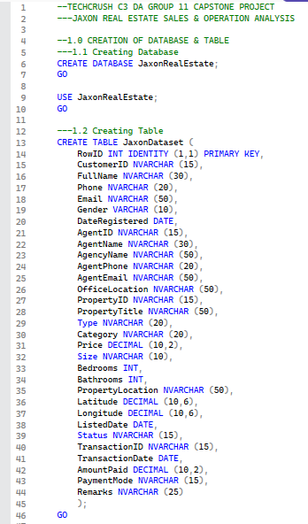

Figure 2.1: Creating Database & Table for Jaxon Dataset

2.2 Data Loading
The dataset was imported into the SQL Server environment using the BULK INSERT command. This method enables fast and efficient loading of large CSV files directly into the database table. The dataset file JaxonRealEstateDataCSV.csv served as the source file for the import process.
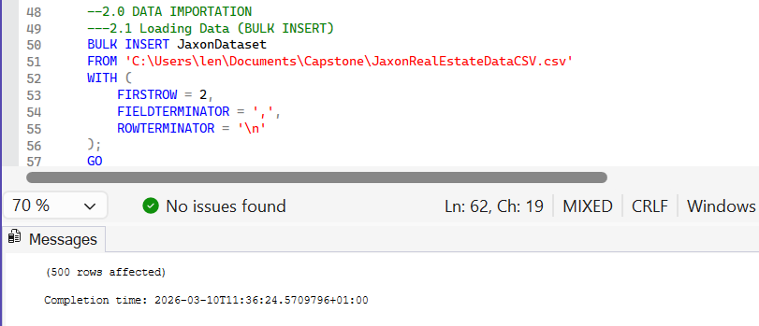

Figure 2.2: Loading Dataset using BULK INSERT

2.3 Import Validation
After importing the dataset, validation queries were executed to confirm successful data loading. The following checks were performed:
- Counting the total number of records in the dataset
- Displaying the first 50 rows of the dataset
These steps ensured that the dataset was successfully imported, data columns aligned correctly with the table structure, and no truncation or formatting issues occurred during import.
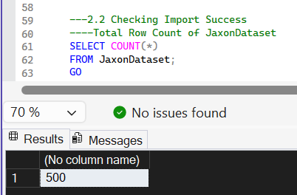

Figure 2.3: Total Number of Records in the Table

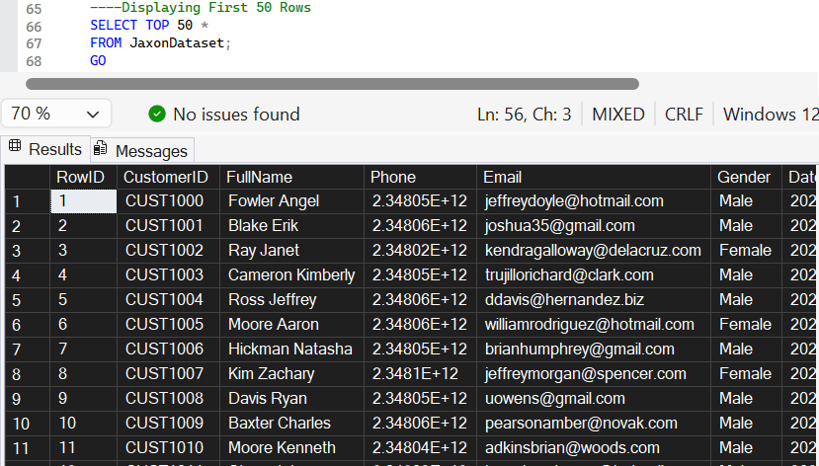

Figure 2.4: Displaying first 50 rows of imported data

3.0 DATA CLEANING & PREPROCESSING
Data cleaning was necessary to improve the reliability and analytical value of the dataset before performing further analysis.

3.1 Identification of Missing Values
Initial checks revealed that some records contained zero values in the Price and AmountPaid columns. Since property prices and transaction payments cannot realistically be zero in real estate transactions, these values were interpreted as missing data placeholders.
Queries were therefore used to count:
- Records where Price = 0
- Records where AmountPaid = 0

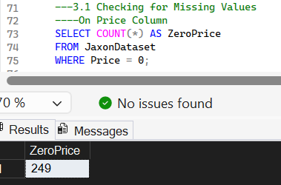

Figure 3.1a: Total Number of Missing Values on Price Column

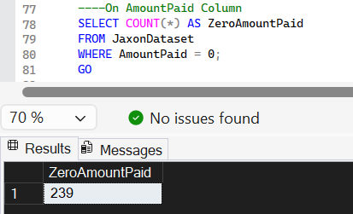

Figure 3.1b: Total Number of Missing Values on AmountPaid Column

A total of 249 zero values were identified in the Price column, while 239 zero values were identified in the AmountPaid column. This indicates that a significant portion of the dataset lacked complete financial information, requiring further data cleaning and imputation steps to ensure the dataset was suitable for reliable analysis.

3.2 Conversion of Invalid Values to NULL
To standardize the dataset, all zero values in the Price and AmountPaid columns were converted to NULL values. This allows SQL functions and statistical calculations to correctly recognise missing data.
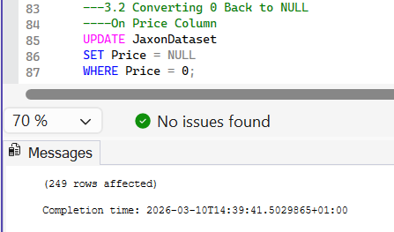

Figure 3.2a: All Price Zero Values converted to NULL

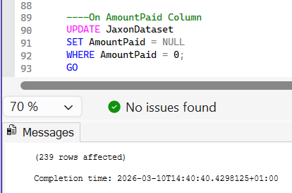

Figure 3.2b: All AmountPaid Zero Values converted to NULL

3.3 Missing Data Assessment
Further checks were performed to identify the distribution of missing values across the dataset. Three key scenarios were examined:
- Records where both Price and AmountPaid were missing
- Records where Price was missing but AmountPaid was available
- Records where AmountPaid was missing but Price was available
This classification allowed targeted cleaning strategies to be applied.
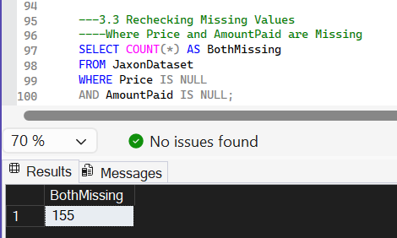

Figure 3.3a: Records where both Price and AmountPaid were missing
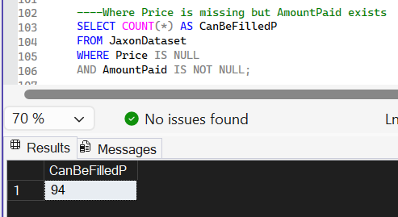

Figure 3.3b: Records where Price was missing but AmountPaid was available

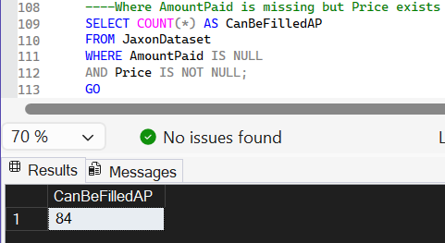

Figure 3.3c: Records where AmountPaid was missing but Price was available

The missing data assessment revealed 155 records where both Price and AmountPaid were missing, 94 records where Price was missing but AmountPaid was available, and 84 records where AmountPaid was missing while Price was available. This distribution provided a clear basis for applying targeted data cleaning strategies, such as cross-column value imputation and median-based estimation, to improve the completeness of the dataset.

3.4 Cross-Column Value Imputation
Where possible, missing values were filled using corresponding values from related columns.
Two logical assumptions were applied:
- Filling Missing Property Prices
If the transaction amount was available but the property price was missing, the AmountPaid value was used to populate the Price column.
- Filling Missing Transaction Payments
Similarly, if AmountPaid was missing but the property price existed and a transaction ID was recorded, the property price was used to estimate the transaction payment.
This step significantly reduced the number of missing values.
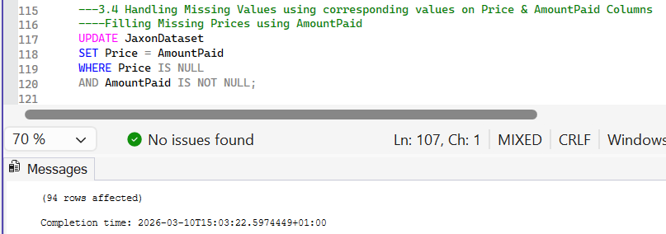

Figure 3.4a: Filled Missing Price Values using the corresponding AmountPaid Values

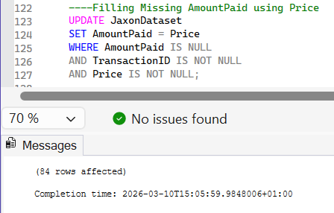

Figure 3.4b: Filled Missing AmountPaid Values using the corresponding Price Values

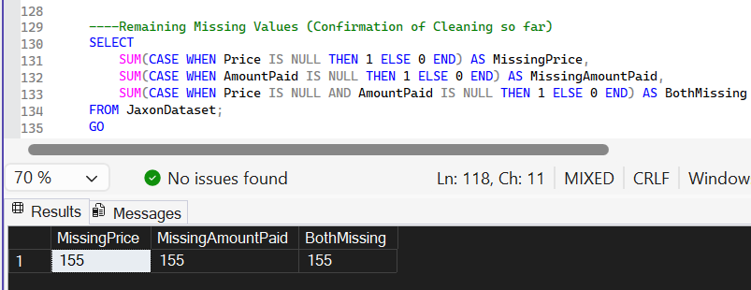

Figure 3.4c: Remaining Missing Values

After applying cross-column imputation, 94 missing values in the Price column were successfully filled using the corresponding AmountPaid values, while 84 missing values in the AmountPaid column were filled using the corresponding Price values. Following this process, 155 records still contained missing values in both the Price and AmountPaid columns, indicating cases where neither field contained sufficient information for direct imputation and therefore required further statistical estimation methods.

3.5 Median-Based Price Imputation
For records where the property price remained missing after the previous step, a median-based estimation approach was used.
The median price was calculated for properties grouped by:
- Property Location
- Property Title
Median was selected instead of mean because it is less sensitive to extreme property prices and provides a more stable estimate for real estate values. The calculated median values were then used to fill missing prices within each property group.

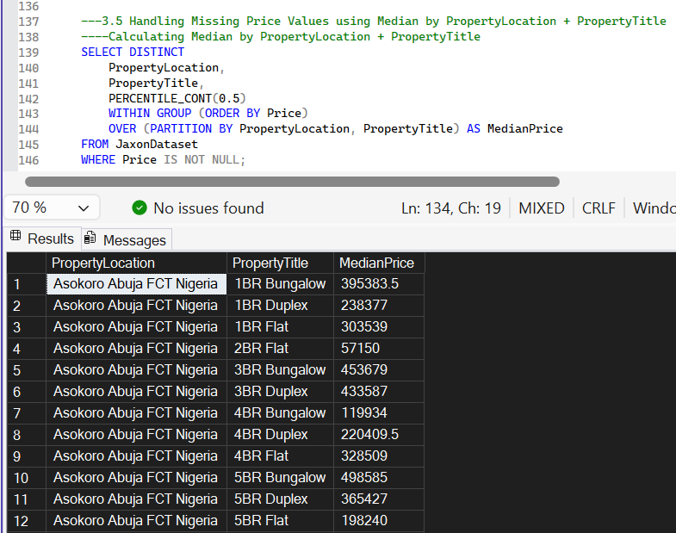

Figure 3.5a: Median by PropertyLocation and PropertyTitle

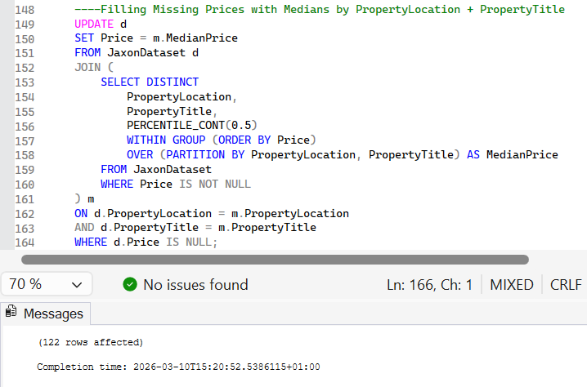

Figure 3.5b: Filled NULL Price Values with Median by PropertyLocation and PropertyTitle
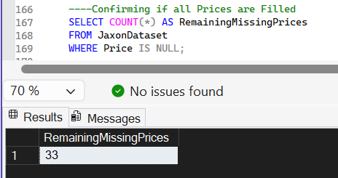

Figure 3.5c: Total Count of Remaining NULL Price Values

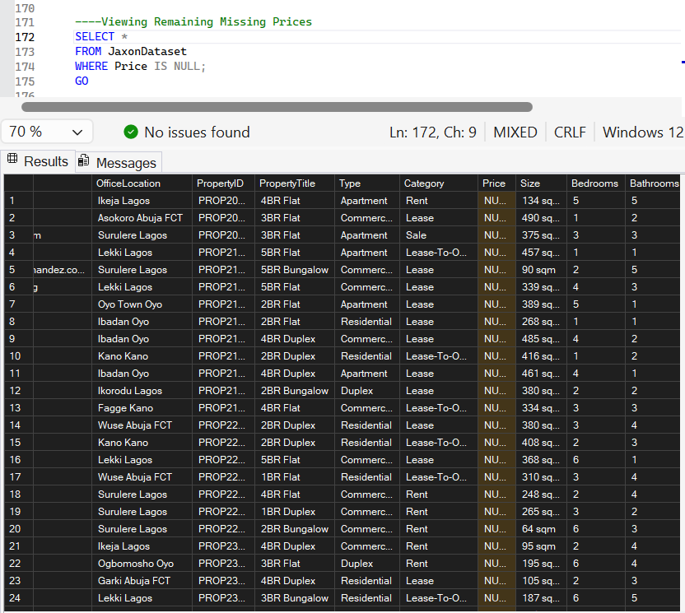

Figure 3.5d: Displaying the Remaining NULL Price Values

After applying median-based estimation grouped by PropertyLocation and PropertyTitle, a total of 122 missing values in the Price column were successfully imputed. However, 33 records still remained with NULL values, indicating that some property groups lacked sufficient existing price data to compute a median value. These remaining cases required a broader imputation approach in the subsequent step.

3.6 Secondary Median Imputation
After the first imputation stage, a small number of records still had missing property prices. To address these cases, a secondary median calculation was performed using PropertyTitle only as the grouping variable. This broader grouping allowed the remaining missing prices to be estimated using the typical price associated with each property title.

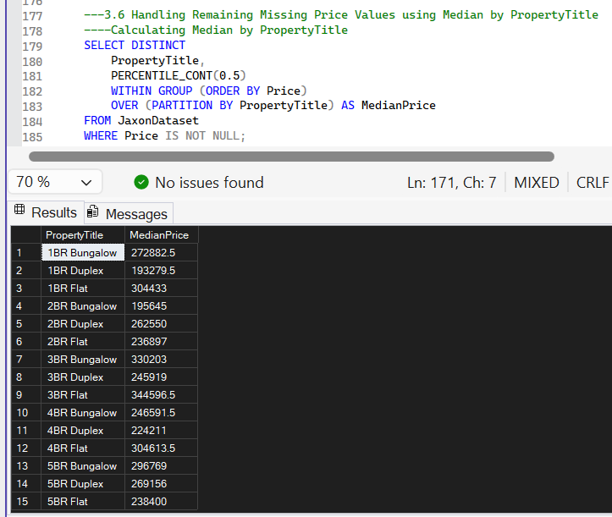

Figure 3.6a: Median by PropertyTitle Only

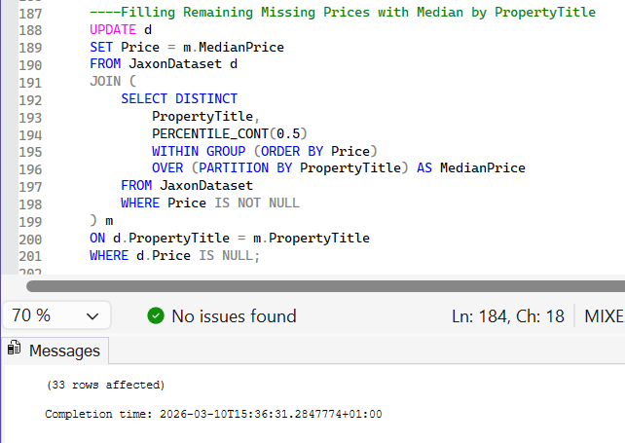

Figure 3.6b: Filled Remaining NULL Price Values with Median by PropertyTitle Only

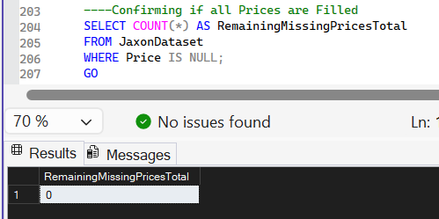

Figure 3.6c: Count of Remaining NULL Price Values
After applying the secondary median imputation based on PropertyTitle only, the remaining 33 missing Price values were successfully filled. As a result, no missing values remained in the Price column, indicating that the property price data had been fully completed and was ready for further analysis.

3.7 Validation of Cleaned Dataset
After completing the data cleaning procedures, validation queries were executed to confirm that the dataset was properly cleaned. The checks included:
- Verifying that all property prices were successfully populated
- Reviewing sample rows from the cleaned dataset
- Ensuring column consistency and data accuracy
These steps confirmed that the dataset was ready for analytical processing.

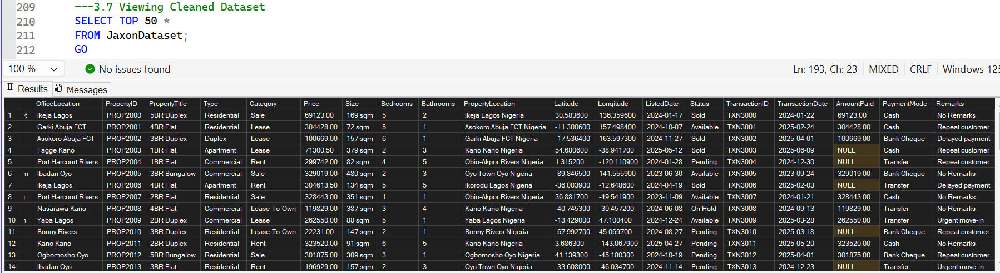

Figure 3.7: First Rows of the Cleaned & Imputed Dataset

All missing values in the Price column were successfully resolved through the applied imputation techniques. However, 155 missing values remained in the AmountPaid column. These records originally contained missing values in both Price and AmountPaid, leaving no reliable basis for estimation. Since AmountPaid represents actual financial transactions, imputing values could introduce artificial revenue figures and distort financial analysis. Therefore, the remaining missing values were retained as NULL and excluded from revenue-related calculations.

4.0 DATA NORMALIZATION (THIRD NORMAL FORM)
To improve data organization and prepare the dataset for business intelligence analysis, the dataset was normalized following the principles of Third Normal Form (3NF). Normalization reduces redundancy and improves relational data structure. Four separate views were created to represent distinct entities in the dataset.

Table 2: Views created from the Jaxon Dataset
Views | Content
Customers View | Customer Information
Agents View | Agent and Agency details
Properties View | Property details
Transactions View | Sales Records

4.1 Customers View
The Customers_View was created to store customer-related information. Attributes included:
- Customer ID
- Full Name
- Phone Number
- Email Address
- Gender
- Registration Date
This view isolates customer data and removes duplicate records.

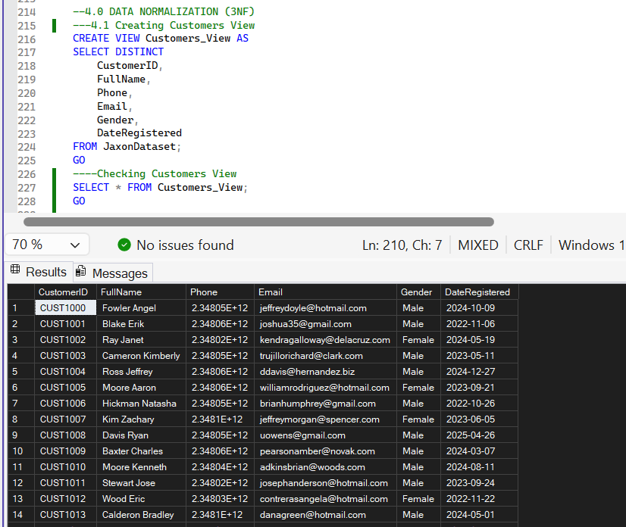

Figure 4.1: Customers View

4.2 Agents View
The Agents_View contains information related to real estate agents and agencies.
Key fields include:
- Agent ID
- Agent Name
- Agency Name
- Contact Information
- Office Location
Separating this data enables easier analysis of agent performance and agency productivity.

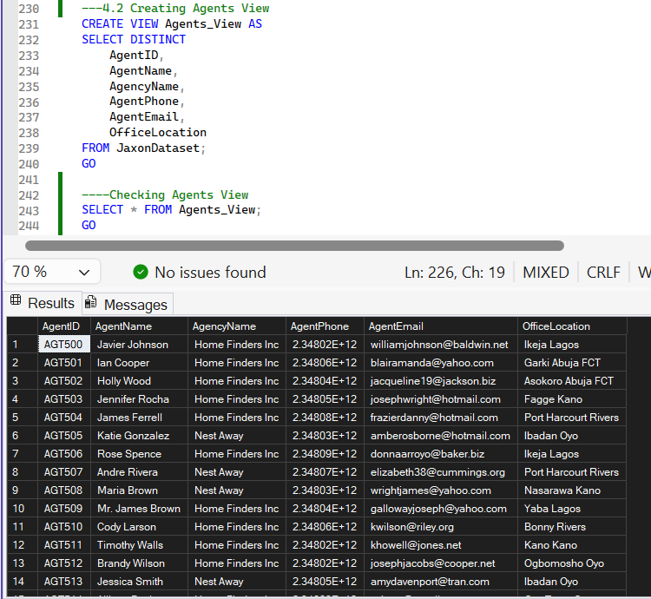

Figure 4.2: Agents View

4.3 Properties View
The Properties_View captures property-specific information including:
- Property ID
- Property Title
- Property Type
- Category
- Size
- Number of Bedrooms
- Number of Bathrooms
- Geographic Location
- Listing Date
- Property Status
This structure supports property market analysis and listing performance evaluation.
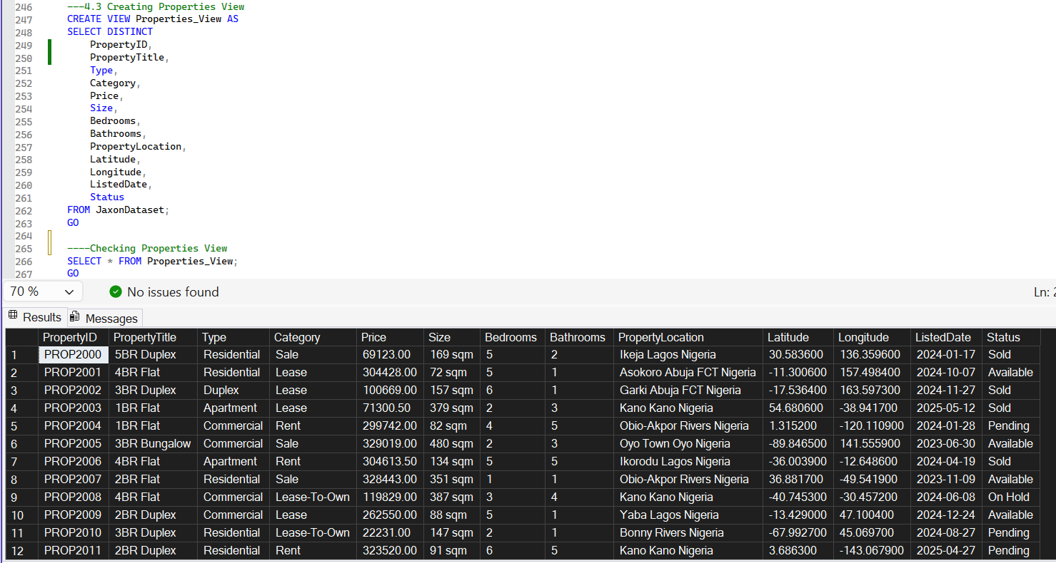

Figure 4.3: Properties View

4.4 Transactions View
The Transactions_View contains all transaction-related data, including:
- Transaction ID
- Customer ID
- Agent ID
- Property ID
- Transaction Date
- Amount Paid
- Payment Mode
- Remarks
Only records with valid transaction IDs were included in this view. This ensures that the dataset accurately reflects recorded transactions.

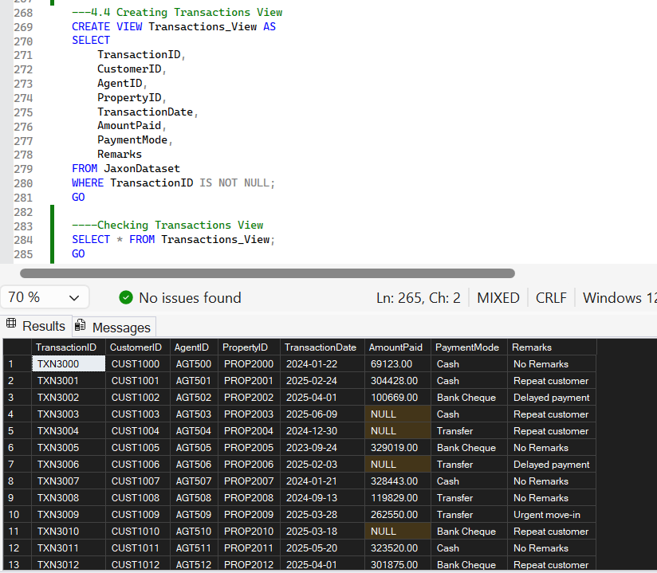

Figure 4.4: Transactions View

4.5 View Verification
Finally, validation queries were executed to confirm the successful creation of all normalized views. Record counts were checked for:
- Customers
- Agents
- Properties
- Transactions
This step ensured that the dataset structure was ready for export and integration with business intelligence tools.

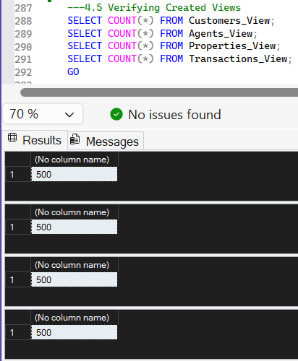

Figure 4.5: Count of records in each View

5.0 DATASET EXPORTATION
The normalized views created in Microsoft SQL Server were exported as CSV files to enable further analysis and integration with data visualization tools. Each view representing the key entities in the dataset: Customers, Agents, Properties, and Transactions; was exported separately to maintain the normalized structure of the data.

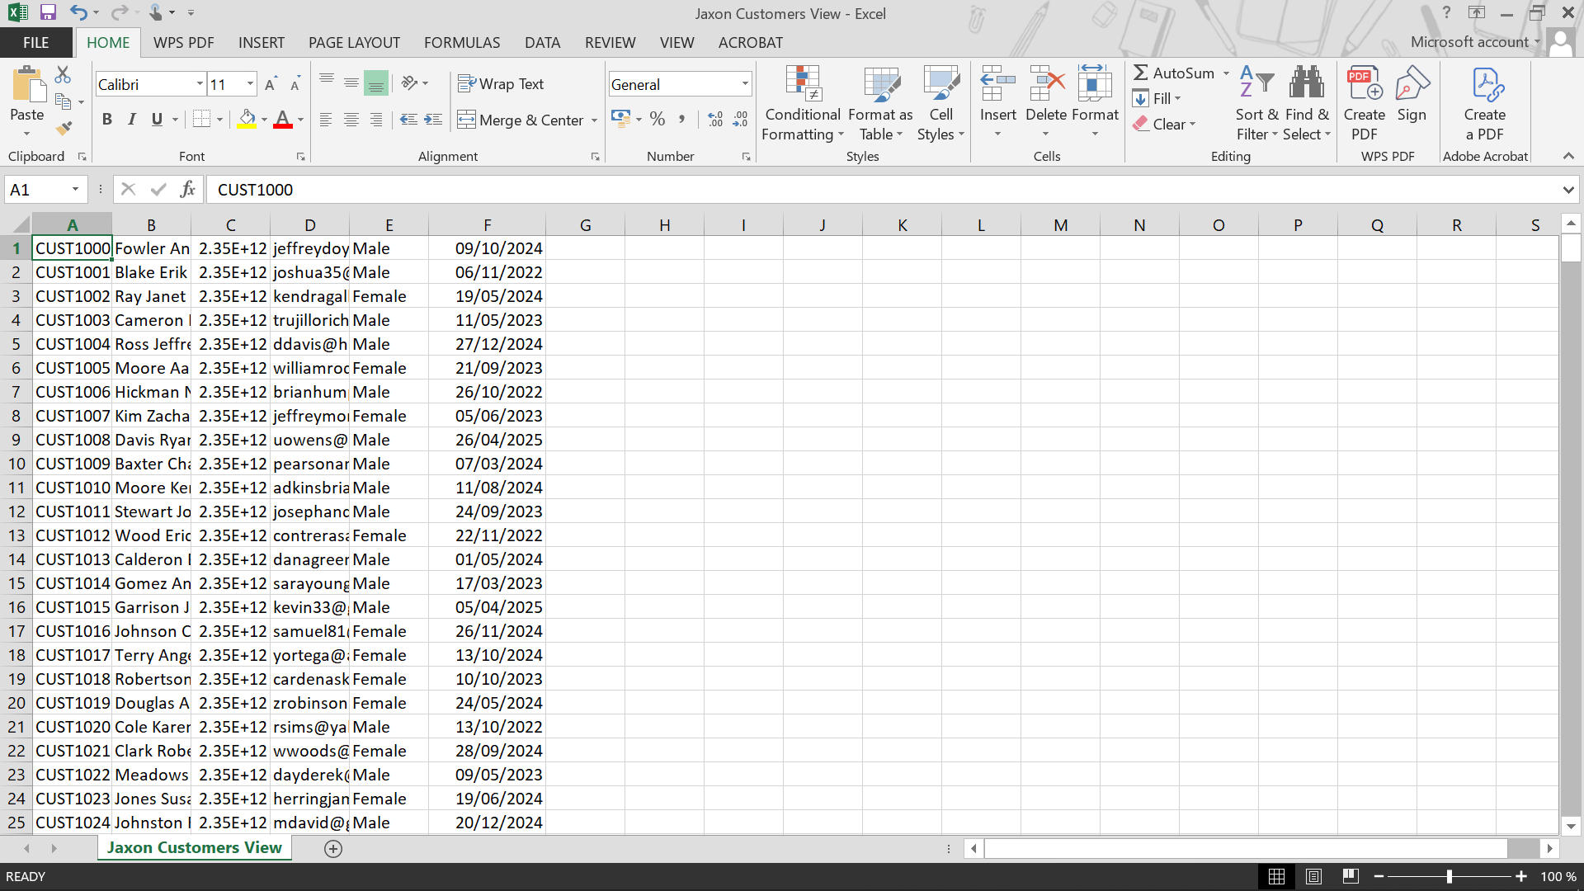

Figure 5.1: Jaxon Customers View (CSV)

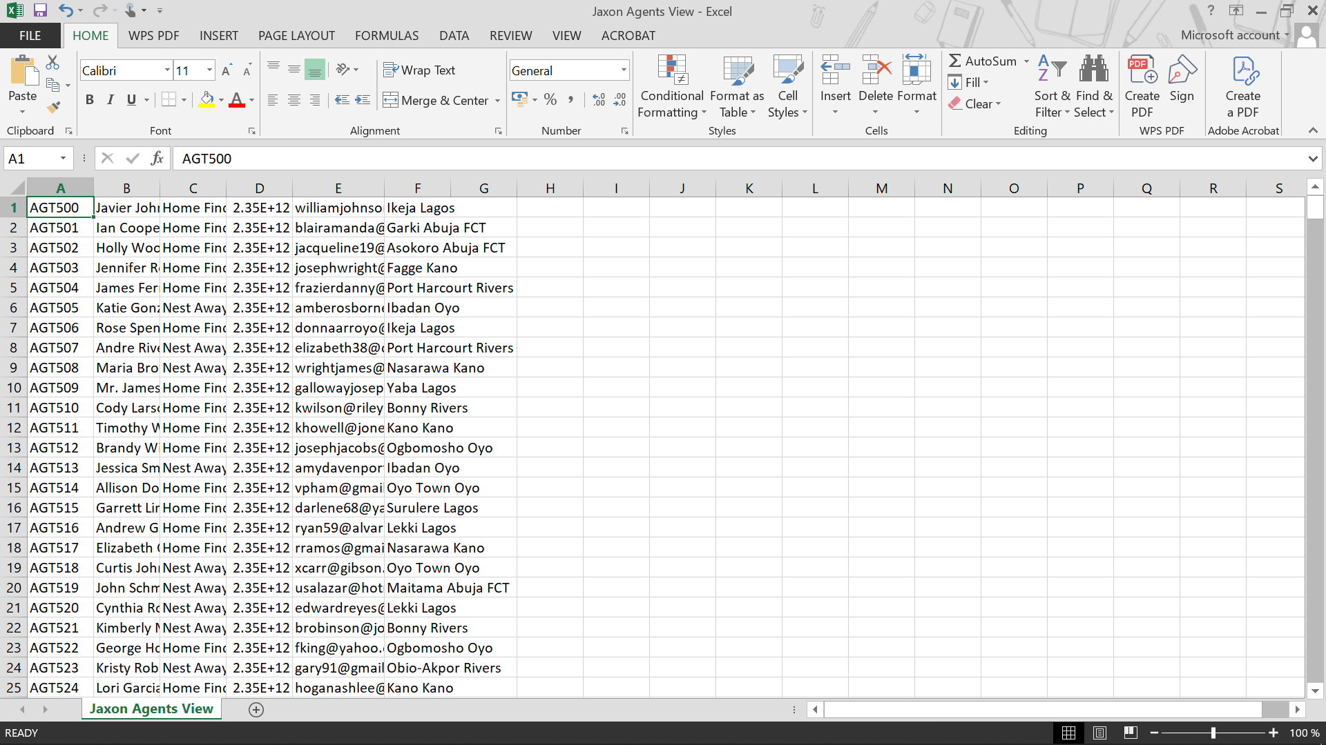

Figure 5.2: Jaxon Agents View (CSV)
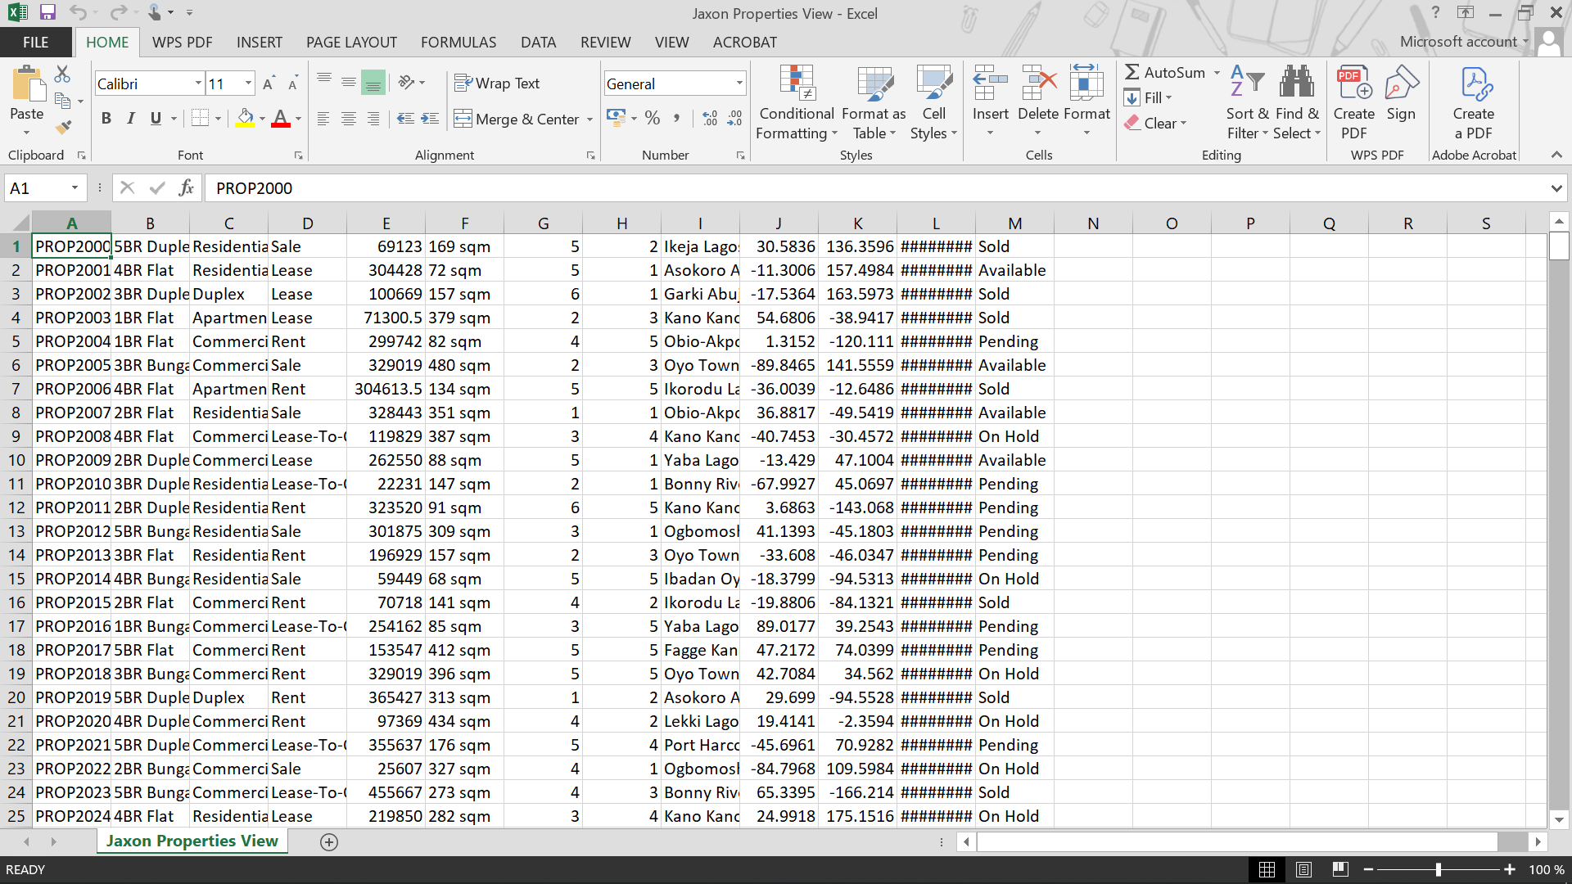

Figure 5.3: Jaxon Properties View (CSV)

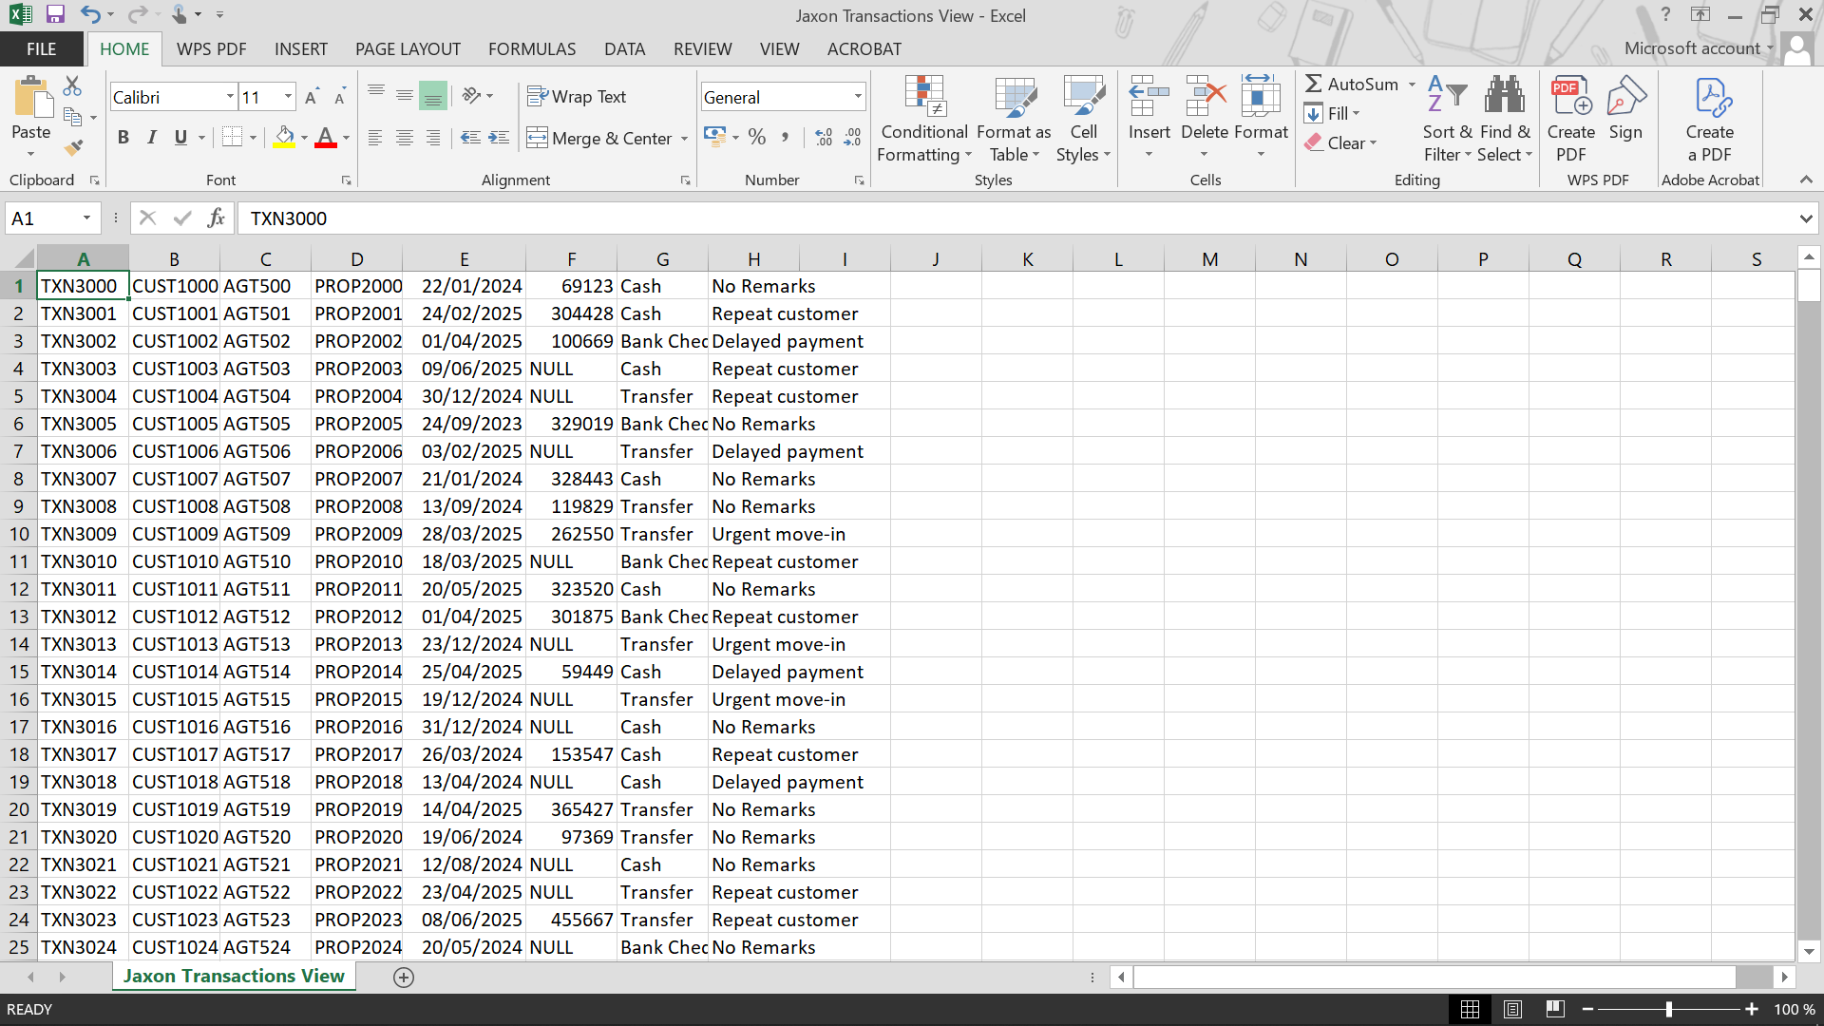

Figure 5.4: Jaxon Transactions View (CSV)

After exportation, the CSV files were converted to Microsoft Excel (.xlsx) format using Microsoft Excel. The converted files were then combined into a single Excel workbook, with each dataset organized into separate worksheets corresponding to their respective entities.
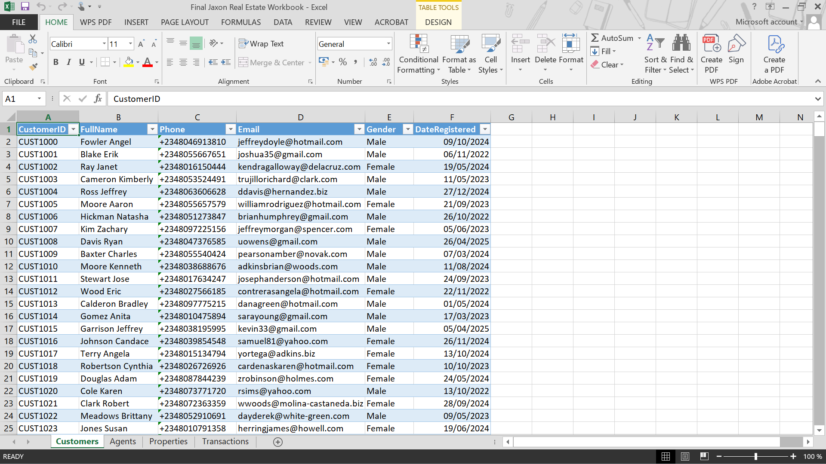

Figure 5.5: Final Jaxon Real Estate Excel Workbook

This approach ensured that the datasets remained structured, organized, and easily accessible for further analysis, data modeling, and dashboard development in Microsoft Excel & Power BI.

